Struct

What is an Struct?
# Source: AI Source: Provided by: [Data Path: Persons Table -> ID Column: 1, Name_En Column: Motasem Essam] -> From: [Chatgpt (GPT‑5 Mini)] on [12/10/2025]
A struct (structure) is a user-defined data type that allows you to group different types of variables together under one name.
It is commonly used in languages like C and C++ to store related data in a single unit.

Why struct is Used
# Source: AI Source: Provided by: [Data Path: Persons Table -> ID Column: 1, Name_En Column: Motasem Essam] -> From: [Chatgpt (GPT‑5 Mini)] on [12/10/2025]
struct helps when you want to store multiple related values about one object.
Example:
A student has:
- name
- age
- grade
Instead of creating separate variables, you can store them in one structure.

Example of a struct

C / C++ Example
# Source: AI Source: Provided by: [Data Path: Persons Table -> ID Column: 1, Name_En Column: Motasem Essam] -> From: [Chatgpt (GPT‑5 Mini)] on [12/10/2025]
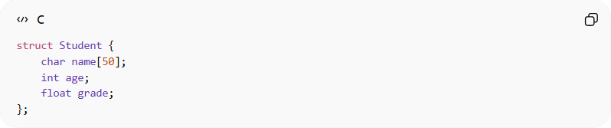
struct Student {
char name[50];
int age;
float grade;
};
This structure stores:
- name → text
- age → integer
- grade → decimal number

Creating a Structure Variable
# Source: AI Source: Provided by: [Data Path: Persons Table -> ID Column: 1, Name_En Column: Motasem Essam] -> From: [Chatgpt (GPT‑5 Mini)] on [12/10/2025]
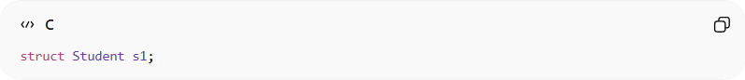
struct Student s1;
Now s1 can store student information.

Assigning Values
# Source: AI Source: Provided by: [Data Path: Persons Table -> ID Column: 1, Name_En Column: Motasem Essam] -> From: [Chatgpt (GPT‑5 Mini)] on [12/10/2025]
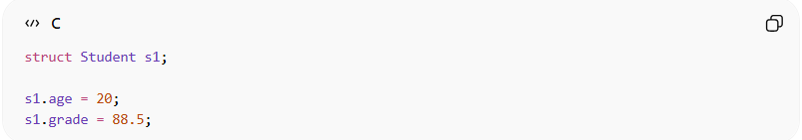
struct Student s1;

s1.age = 20;
s1.grade = 88.5;
For strings:
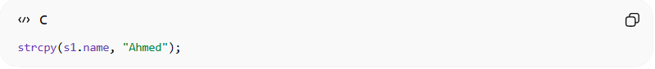
strcpy(s1.name, "Ahmed");

Accessing Structure Members
# Source: AI Source: Provided by: [Data Path: Persons Table -> ID Column: 1, Name_En Column: Motasem Essam] -> From: [Chatgpt (GPT‑5 Mini)] on [12/10/2025]
Use the dot operator .
Example:
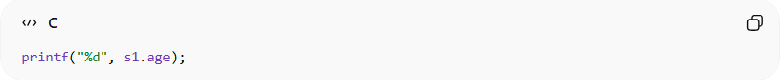
printf("%d", s1.age);

Example Program
# Source: AI Source: Provided by: [Data Path: Persons Table -> ID Column: 1, Name_En Column: Motasem Essam] -> From: [Chatgpt (GPT‑5 Mini)] on [12/10/2025]
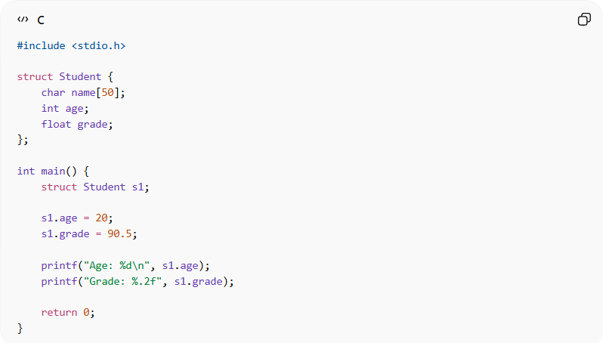
#include <stdio.h>

struct Student {
char name[50];
int age;
float grade;
};

int main() {
struct Student s1;

s1.age = 20;
s1.grade = 90.5;

printf("Age: %d\n", s1.age);
printf("Grade: %.2f", s1.grade);

return 0;
}

Real-World Example
# Source: AI Source: Provided by: [Data Path: Persons Table -> ID Column: 1, Name_En Column: Motasem Essam] -> From: [Chatgpt (GPT‑5 Mini)] on [12/10/2025]
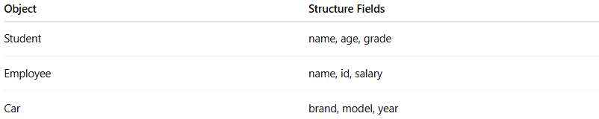
Object | Structure Fields
Student | name, age, grade
Employee | name, id, salary
Car | brand, model, year

Advantages of Struct
# Source: AI Source: Provided by: [Data Path: Persons Table -> ID Column: 1, Name_En Column: Motasem Essam] -> From: [Chatgpt (GPT‑5 Mini)] on [12/10/2025]
- Organizes related data into a single unit
- Allows storing different data types together
- Makes programs easier to read and manage
- Helps create complex data models
- Can be used to build more advanced data structures (like linked lists, trees, etc.)

Disadvantages of Struct
# Source: AI Source: Provided by: [Data Path: Persons Table -> ID Column: 1, Name_En Column: Motasem Essam] -> From: [Chatgpt (GPT‑5 Mini)] on [12/10/2025]
- No built-in functions or methods (in C)
- Cannot support inheritance or advanced object-oriented features
- Large structures may consume more memory
- Sometimes requires extra code to manage data

